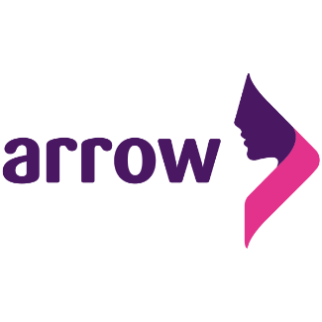
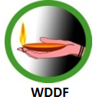

46th Session of the Human Rights Council (HRC)
Annual Debate: Rights of Persons with Disabilities (res. 7/9, 42/23)

Dear Chair,
I am making this statement on behalf of the Asian-Pacific Resource and Research Centre for Women (ARROW) and Women with Disabilities in Development Foundation (WDDF). This statement has been endorsed by 19 organisation and network of Disabled People's Organisation (DPOs).
Rights of persons with disabilities is a human right that is indivisible as laid out in the Convention on the Rights of Persons with Disabilities. Implementation of convention provisions, through development and application of inclusive policies and initiatives is key to establishing rights of persons with disabilities, particularly women and girls with disabilities and their sexual and reproductive health and rights.
Community-level awareness raising is required targeting the myths and misconceptions surrounding sexuality of women and girls with disabilities. Focus on skills development of service providers along with digital transformation in health services have the potential to achieve this. Increase in the digital literacy of women and girls with disabilities, will enable them to utilise digital technology to access health services and information that is inclusive, affordable, free from discrimination, stigma and harassment, especially in the context of a pandemic or when faced with sexual and gender-based violence.
Non-priority around sexual and reproductive health rights of women and girls with disabilities means that harmful practices committed against them such as - forced sterilization, forced abortion and forced institutionalization - will continue to go unaddressed. We must therefore stand united to advance the rights of women and girls with disabilities and bring an end to the life-time discrimination routinely faced by them affecting their decision making around their bodies, sexuality, and their lives.
This statement has been endorsed by the following organisation and network of DPOs (in no particular order):
- Laxmi Nepal, Blind Women Association, Nepal
- Shampa Sengupta - Sruti Disability Rights Centre, Kolkata, India
- Protik Mohila O Sheshu Sangstha, Bangladesh
- Bangladesh ProtibandhiUnnayanSangstha (BPUS), Bangladesh
- Centre for Disability in Development (CDD), Bangladesh
- Nagorik Uddyog (Citizen's Initiative), Bangladesh
- National Council of Disabled Women (NCDW) - a network of over 100 DPOs in Bangladesh
- ADD International, Bangladesh
- Ain O Shalish Kendra (ASK), Bangladesh
- Bandhu Social Welfare, Bangladesh
- Disabled Child Foundation (DCF), Bangladesh
- Protik Mohila O Sheshu Sangstha, Bangladesh
- Bangladesh Society for the Change and Advocacy Nexus (B-SCAN), Bangladesh
- Access Bangladesh Foundation, Bangladesh
- Leonard Cheshire, Bangladesh Country Office, Bangladesh
- Human Rights Disability and Development Foundation (HDDF), Bangladesh
- Manikgonj Disabled Peoples Organization to Development (MDPOD), Bangladesh
- National Grassroot Disabled peoples’ Organization (NGDO), Bangladesh
- Society of the Deaf & Sign Language Users (SDSL), Bangladesh

